BIOCANE DINING

(Sugarcane waste utensils)

A

PROJECT IDEA

FOR PARTIAL FULFILMENT

OF

DEGREE OF MASTER’S OF BUSINESS ADMINISTRATION

**MBM-644**

# SUBMITTED TO: - SUBMITTED BY: -

Prof. K. Santi Swarup **Group No. 17**

Hari Kishen

Kashish khan

Mayank Kumar

Saurabh Singh

Abhinav Parashar

Pratham Gaur

Rudra Pratap Singh

**DAYALBAGH EDUCATIONAL INSTITUTE**

(**DEEMED UNIVERSITY)**

 **Dayalbagh Educational Institute**

**Dayalbagh, Agra**

**CERTIFICATE**

This is to certify that the entitled Dissertation Project **“A Business Plan on Sugarcane waste utensils”** has been prepared and submitted by:

|  |  |  |
| --- | --- | --- |
| **Sr.** | **Members** | **Roll No.** |
| 1 | Hari Kishen | 2302195 |
| 2 | Kashish khan | 2302201 |
| 3 | Mayank Kumar | 2302210 |
| 4 | Saurabh Singh | 2302243 |
| 5 | Abhinav Parashar | 2302911 |
| 6 | Pratham Gaur | 2302937 |
| 7 | Rudra Pratap Singh | 2302940 |

Towards partial fulfilment of the requirements for the award of the degree of **M.B.A** of Faculty of Social Science, Dayalbagh Educational Institute, Dayalbagh, Agra. The work is original and I forward it with remark that the contents are genuine. I recommended that the merit of the dissertation be assessed according to the rule of D.E.I. (Deemed University) for award of Master of Business Administration.

**Prof. K. Santi Swarup**

Department of Social Science

Dayalbagh Educational Institute

**ACKNOWLEDGMENT**

In the present world of competition, there is a race of existence in which those are having will to come forward succeed. Project is like a bridge between theoretical and practical working. With this willing, we joined this particular project. First of all, we would like to thank the Supreme Power, the Almighty God who is obviously the one has always guided me to work on the right path of life. Without his grace, this project could not become a reality. Next to him are our parents whom we are greatly indebted to them that they brought us up with love and encouragement to this stage. We are feeling obliged in taking the opportunity to sincerely thank to **Prof. K. Santi Swarup Sir,** Dayalbagh Educational Institute, Dayalbagh, Agra. We are highly obliged in taking the opportunity to sincerely thanks to all the staff members of Social Science Faculty Department for their generous attitude and friendly behavior. At last, but not the least, we are thankful to all our teachers and friends who have been always helping and encouraging us throughout the year. We have no valuable words to express our thanks, but our heart is still full of the favors received from every person.

**TABLE OF CONTENTS**

|  |  |  |
| --- | --- | --- |
| **S. No.** | **Topic** | **Page No.** |
| 1 | Business canvas model of edible cutlery | II |
| 2 | Types of product manufacturers | III |
| 3 | Description of manufacturing process | 1 |
| 4 | Supply chain network process | 2 |
| 5 | Strategy- How to launch it:   * Pre launching phase * Launching phase * Post launching phase | 3 |
| 6 | Production machineries and its process | 4-7 |
| 7 | ANSOFF matrix | 8-9 |
|  |  | 10 |

**COMPANY NAME- BIOCANE DINING**

**COMPANY LOGO-**

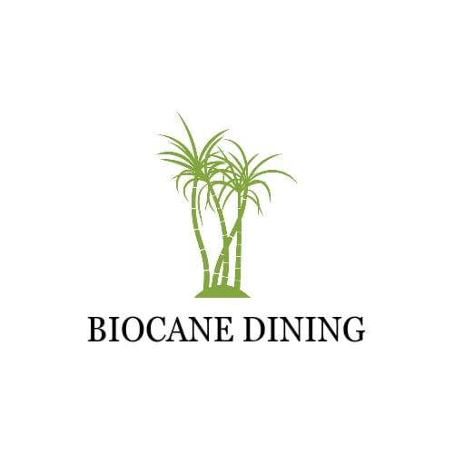

# BUSINESS MODEL

The Business Model Canvas is a visual framework that serves as a strategic tool for developing, describing, and analyzing the fundamental aspects of a business. Comprising nine essential building blocks, this canvas offers a holistic view of how a company creates, delivers, and captures value. The customer segments section identifies target markets, ranging from eco-conscious consumers to event organizers and restaurants.

Value propositions outline the unique advantages of sugarcane utensils, emphasizing sustainability, biodegradability, and customizable designs for events. Channels describe how the products reach customers through online platforms, collaborations with eco-friendly retailers, and partnerships with event planning companies. Customer relationships focus on educational content, responsive customer support, and loyalty programs. Revenue streams detail direct sales, bulk orders for events, and licensing agreements for manufacturing.

Key resources encompass sugarcane fiber suppliers, production facilities, and an online sales platform. Key activities involve research and development, marketing campaigns, and collaborations with suppliers. Key partnerships include sustainable packaging providers, event planning companies, and eco-friendly certification bodies. The cost structure covers raw material procurement, manufacturing costs, and marketing expenses. In summary, the Business Model Canvas provides a structured and visual approach to understanding, developing, and optimizing the core elements of a business model.

**1. Customer Segments:**

- Eco-conscious consumers: Individuals who prioritize environmentally friendly products and are willing to make sustainable choices.

- Event organizers (weddings, parties): Professionals or individuals planning events seeking eco-friendly alternatives for disposable utensils.

- Restaurants and catering services: Businesses aiming to enhance their sustainability practices and offer eco-friendly options to their customers.

**2. Value Propositions:**

- Sustainable alternative to plastic utensils: Sugarcane utensils offer a biodegradable and compostable alternative, reducing environmental impact.

- Biodegradable and compostable: Highlighting the eco-friendly nature of the product, appealing to environmentally conscious consumers.

- Customizable designs for events: Offering personalized options for events, adding a touch of uniqueness while being sustainable.

**3. Channels:**

- Online platform for direct consumer sales: Utilizing a dedicated website or online marketplace to directly reach and sell to individual consumers.

- Collaborations with eco-friendly retailers: Partnering with stores that share similar values to expand the reach of sugarcane utensils.

- Partnerships with event planning companies: Collaborating with event organizers to supply sustainable utensils for various occasions.

**4. Customer Relationships:**

- Educational content on environmental impact: Providing information on the ecological benefits of sugarcane utensils to raise awareness.

- Responsive customer support for customization: Offering assistance and guidance to customers seeking customized solutions for their events.

- Loyalty programs for repeat customers: Implementing loyalty programs to reward and retain customers who consistently choose sugarcane utensils.

5. Revenue Streams:

- Direct sales through online platform: Generating revenue by selling sugarcane utensils directly to consumers through the online platform.

- Bulk orders for events and restaurants: Catering to larger orders from event organizers, restaurants, and catering services.

- Licensing agreements for manufacturing: Earning revenue through licensing the production of sugarcane utensils to other manufacturers.

**6. Key Resources:**

- Sugarcane fiber suppliers: Establishing reliable sources for high-quality sugarcane fiber, a crucial raw material.

- Production facilities for utensil manufacturing:Access to facilities equipped for the efficient production of sugarcane utensils.

- Online platform for sales and marketing: Investing in and maintaining an effective online platform for sales, marketing, and customer engagement.

**7. Key Activities:**

- Research and development for product improvement: Continuously innovating and enhancing the quality and features of sugarcane utensils.

- Marketing and promotion campaigns: Implementing strategies to create awareness and promote the benefits of sugarcane utensils.

- Collaborations with suppliers and manufacturers: Building and maintaining strong relationships with sugarcane fiber suppliers and manufacturing partners.

**8. Key Partnerships:**

- Sustainable packaging providers: Collaborating with companies that offer eco-friendly packaging solutions to complement the utensils.

- Event planning companies: Forming partnerships with organizations involved in event planning to ensure a steady demand for sugarcane utensils.

- Eco-friendly certification bodies: Seeking certifications that verify the sustainability and environmental friendliness of the utensils.

**9. Cost Structure**:

- Raw material procurement: Costs associated with acquiring sugarcane fiber sustainably.

- Manufacturing and production costs: Expenses related to the manufacturing process, including labor and equipment.

- Marketing and promotional expenses: Budget allocated for advertising, creating awareness, and promoting sugarcane utensils.

**Types Of Product Manufacturers**

Products made from sugarcane waste cutlery typically fall under the category of eco-friendly and sustainable alternatives to traditional disposable items. Here are some types of products that can be manufactured from sugarcane waste:

* Disposable Plates: Single-use plates made from sugarcane bagasse, providing a biodegradable alternative to traditional paper or plastic plates.
* Bowls and Containers: Biodegradable bowls and containers suitable for serving various food items, commonly used in the food service industry.
* Cups and Lids: Environmentally friendly cups and lids made from sugarcane waste, offering a sustainable option for hot and cold beverages.
* Cutlery Sets: Disposable forks, knives, and spoons made from sugarcane bagasse, providing an eco-friendly alternative to traditional plastic cutlery.
* Trays and Clamshells: Compostable trays and clamshells suitable for packaging and serving food, commonly used in fast-food and takeout settings.
* Stirrers and Straws: Biodegradable stirrers and straws made from sugarcane waste, offering a sustainable option for stirring drinks and sipping.
* Food Packaging: Sustainable packaging materials for various food items, including wraps, sleeves, and containers made from sugarcane waste.
* Food Service Products: Eco-friendly alternatives for the food service industry, such as meal kits, catering trays, and serving platters.
* These products aim to reduce environmental impact by utilizing sugarcane waste as a raw material, promoting a circular and sustainable approach to single-use items.

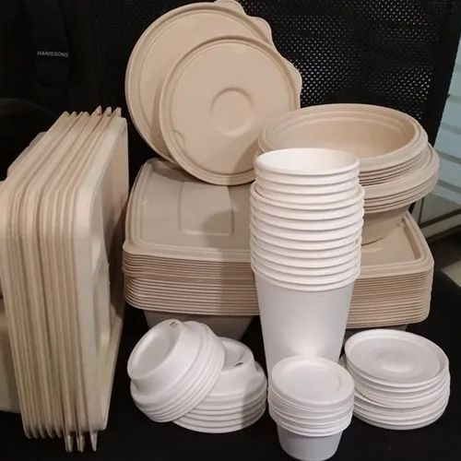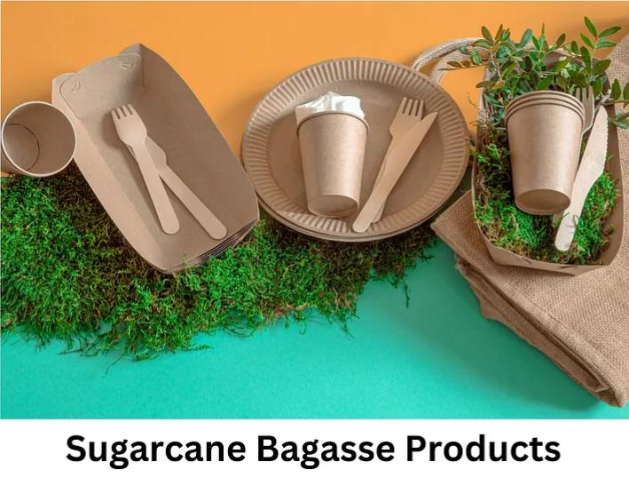

**Description Of Manufacturing Process**

The manufacturing process for sugarcane waste utensils typically involves several key steps:

**1. Collection of Sugarcane Waste:**

- Sugarcane waste, also known as bagasse, is collected from sugar mills where it is a byproduct of sugar extraction.

**2. Cleaning and Processing:**

- The collected bagasse undergoes cleaning and processing to remove impurities and any remaining sugar content.

**3. Pulping:**

- Bagasse is then pulped by breaking down the fibers into a pulp using water and sometimes chemicals. This process results in a fibrous material suitable for molding.

**4. Molding:**

- The pulped sugarcane waste is molded into the desired utensil shapes using high-pressure molds. This can include molds for plates, bowls, cutlery, and other utensils.

**5. Drying:**

- The molded utensils are dried to remove excess moisture. This can be done through air drying or using industrial drying processes.

**6. Finishing and Trimming:**

- The dried utensils undergo finishing processes where any rough edges or irregularities are trimmed, creating a smooth and refined final product.

**7. Packaging:**

- Once the sugarcane waste utensils are finished, they are packaged for distribution. The packaging is often designed to be minimalistic and eco-friendly, aligning with the sustainable nature of the products.

It’s important to note that the manufacturing process for sugarcane waste utensils is designed to be environmentally friendly, utilizing a byproduct that would otherwise be considered waste. The resulting utensils are biodegradable and compostable, offering a sustainable alternative to conventional disposable plastic products.

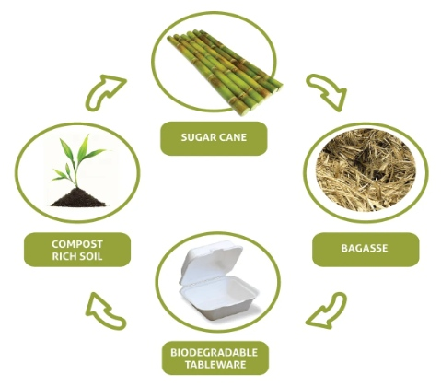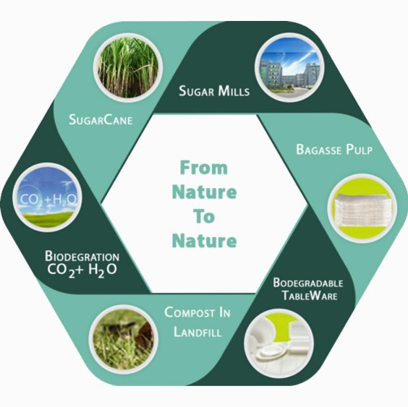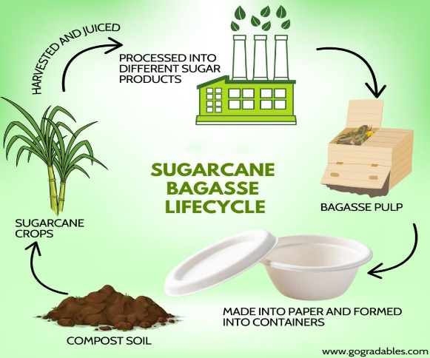

**Revenue streams:**

Product price- customers will pay 1.5 rupee per piece (Less than of plastic cutlery by 1.1 rupee), business will pay 1.3 rupees per piece.

Revenue and cost structure for the next 5 years calculation:

Number of plastic cutlery sales in India = 120 billion units per year

Let assume we set four plants each in North, south, east, and west where each plant produces and sell 1.25 crore edible cutlery initially.

Therefore, total cutlery produces in 4 plants and sell in a year= 4*1.25 crore = 5 crore units per year. (Since, Indian population is 1.34 billion out of which 38 crore lives in urban and are most likely to use the edible cutlery spoons. Assumption taken is that only 5 crore population have once used the spoon in a year.)

So, target market share acquires in the first year = (5/12000) *100 = 0.04%

Let growth rate is assumed to be 20% in the initial 5 years then it becomes stagnant.

Estimated revenue generated in the first year = 5 crore * 1.4 = 7 crore (Rs 1.3 for business units and Rs 1.5 from retailers who sell to the customers, by taking the average)

Cost enquired:

Fixed cost-

Capital, Plant and machinery cost for 4 plants setup = 4*1 crore = 4 crore Supply chain management cost = 1 crore

Salary = (30 workers*4* rupees 30000 + 3 supervisors*4*rupees 50000) = Rupees 42 Lakh Total Fixed cost = 4crore + 42 lakh = 4.42 crore

Variable cost-

Advertisement campaign and promotion cost = 5 % of estimated revenue generated = 35 lakh

Raw material cost=20% of estimated revenue=1.4 Crore Total Variable cost = 1.75crore

Therefore, total cost enquired = 1.75 + 4.42 = 6.17

Let growth rate in each year for the first 5 years is 20 % in the revenue and the variable cost, then it becomes stagnant.

Year 1 Year 2 Year 3 Year 4 Year 5 After 5 years

Revenue 7, 8.4, 10.08, 12.096, 14.515;

Fixed cost 4.42 crore for every year;

Variable cost 1.75, 2.1, 2.52, 3.024, 3.6288;

Margin 0.83, 1.88, 3.14, 4.652, 6.4662.

All units are in crores, CAGR for first 5 years is 20 % while after 5-year growth reduced to 5 % as market become stagnant.

**Production machineries and its process**

Machines Involved in the Process :-

Mixer Machine

Batch Making Machine Forming Machine

Pick and Place Robot

Conveyors Packing Machines

Mixer Machine :- A bakery mixer is designed to produce bread dough or cake batter by bringing dry and liquid ingredients together to form a mass with optimum rheology and handling properties. For a preset product load, efficient mixers should perform their function under optimal mechanical and energy consumption.

**Batch Making Machine** :- An individual bakery batching system, or automation of a combined group of process equipment and systems can be accomplished. Raw material handling systems, e.g. pneumatic and mechanical conveying, liquid weighing and metering systems, bulk bag unloading, micro, minor and major ingredient weighing and batching systems can provided.

**Forming Machine** :- Industrial Forming Equipment for Baked Goods There are various types of forming equipment that can be used on a given production line. Equipment such as Rotary Moulders, Bar Formers, Ultrasonic Guillotines, and various types of Wire Cutters are some of the more common types of forming equipment that are used.

**Pick and place Robot:-** The use of industrial pick and place robotics in the food industry started many years ago with simple load/unload systems, where operators handled packages manually for placing them into machines. Nowadays automated systems continuously manage packaged products without human intervention.

PROCESS:-

Process for production of edible cutlery comprising:

Selecting 10-88 parts of starch;

Adding the said starch to mixer and mix it at 500 rpm;

Adding 10 to 15 parts by weight of high fiber soft wood cellulose or sugarcane bagasse to the mixer;

Adding 15 – 40 parts by weight of water to the mixture;

Adding 1 to 15 parts by weight of nucleating agent to the mixture;

Adding 0.1 to 1 parts by weight of bael fruit or wood apple to the mixture;

Adding 0.1 to 1 parts by weight of jaggery or white sugar to the mixture;

Adding a pinch of the flavoring agent to the mixture;

Adding 0.1 to 0.6 parts by weight of compatibilizer to the mixture;

Heating the mixture for 10 to 25 minutes at a temperature of 40o C to 70o C;

Transferring the said mixture to quantitative machine to get uniform weight of dough;

Transferring the obtained dough to compression molding machine;

Pressing the said mixture at a pressure of 80 to 170 bar for about 5 to 60 seconds, at a temperature ranging from 150 °C to 225° C to form final product;

Taking the said product by lifting movable part of the device;

Spraying the products with water proof coating material;

Drying the obtained product in drying tunnel for 2 to 4 minutes at a temperature ranging from 60°C to 100 °C depending upon the thickness of the coating material; and

Sterilizing and packing of the obtained products.

REFERENCES

* <https://aim2flourish.com/innovations/eco-friendly-sugarcane-cutlery-stronger-than-plastic>
* <https://www.quitplastic.in/sugarcanebagassecutlery>
* <https://enterclimate.com/blog/manufacturing-bio-degradable-cutlery-from-sugarcane-bagasse/>
* <https://www.greenlandinternational.in/sugarcane-bagasse-tableware-making-machine.html>
* <https://yourstory.com/2020/12/startup-bharat-ayodhya-chuk-sugarcane-cutlery-google-amazon-irctc>
* <https://www.pappcoindia.com/>
* <https://hi.m.wikipedia.org/wiki/%E0%A4%AE%E0%A5%81%E0%A4%96%E0%A4%AA%E0%A5%83%E0%A4%B7%E0%A5%8D%E0%A4%A0>